Date: 01/07/2024

Documentation for Emission Application build by Clearance

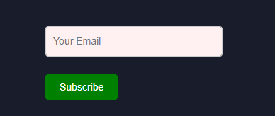

EmissionTrack Application Overview

Introduction
This document outlines the details and functionalities of the EmissionTrack application, covering aspects from the landing page to accessing the main application.

Landing Page Overview
The landing page serves as an introduction to the EmissionTrack website, showcasing what the company offers. Its primary purpose is to attract and engage potential clients, driving more traffic to our site. The landing page provides an overview of the company's mission, services, and value propositions.

Features and Functionalities
- Call-to-Action (CTA) Buttons:
  - The landing page includes several CTA buttons designed to guide users towards different actions, enhancing user engagement and navigation.
- Dynamic Mode:
  - The landing page supports a dynamic mode feature, allowing users to switch between dark mode and light mode by clicking the moon icon. This enhances user experience by catering to individual preferences.
- Navigation Bar Enhancements:
  - The navigation bar now includes a new feature: a blog link. This addition directs users to our blog, providing them with more insights and updates about our company and industry.

- Join Us Button and Countdown:
  - The landing page features a "Join Us" button accompanied by a countdown timer, indicating the time remaining until EmissionTrack's launch. When clicked, a modal form appears, allowing users to sign up and provide their information.
- Subscription Form:
  - Below the "Join Us" section, there is a subscription form where users can enter their email addresses to receive news and updates. After entering their email and submitting the form, users receive a thank you message.
- Email Validation:
  - The subscription form includes email validation to ensure users enter a valid email address. If an email is entered without an "@" sign, a warning message is displayed indicating that the email is invalid. Once a valid email is submitted, a thank you message is displayed.
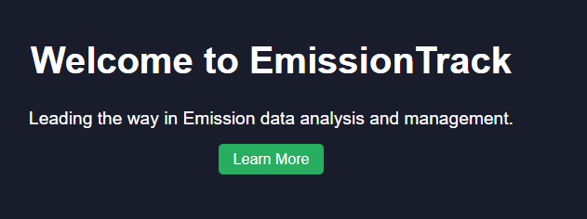
- Login Page Access:
  - Upon clicking the CTA button that redirects to the login page of the main application, users must enter the correct login details to gain access. The default login credentials are:
    - Email: Admin@example.com
    - Password: Admin123!
  - Users cannot log in without providing the correct credentials.

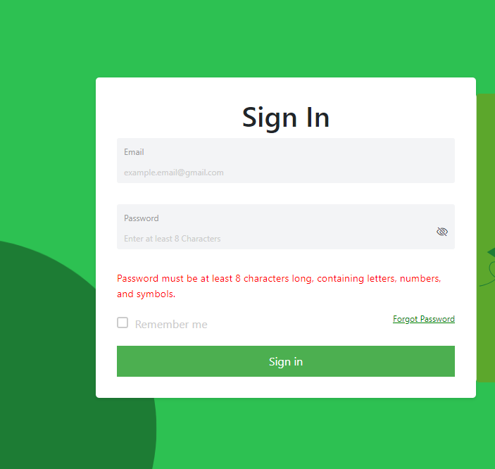 • Once the correct login details are entered, a modal will appear, prompting users to enter the default code. As this is a static application with no database connection, the default code is:
  - Default Code: 629001
- Upon entering the correct code, users will gain access to the dashboard.
• Upload Functionality:
- The application includes an upload functionality where a default image will be associated with any data entered into the data information table.
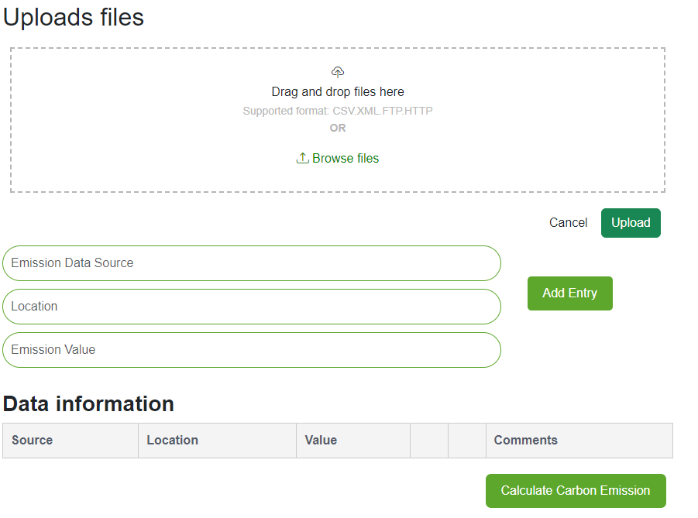 Data Entry and Population:
- In the application, there is a table with editable columns where users can enter their data. Upon entering data into the columns, the table will dynamically update to display the entered information.
- As this is a static application with no data storage, all entered data will be lost upon refreshing the browser.

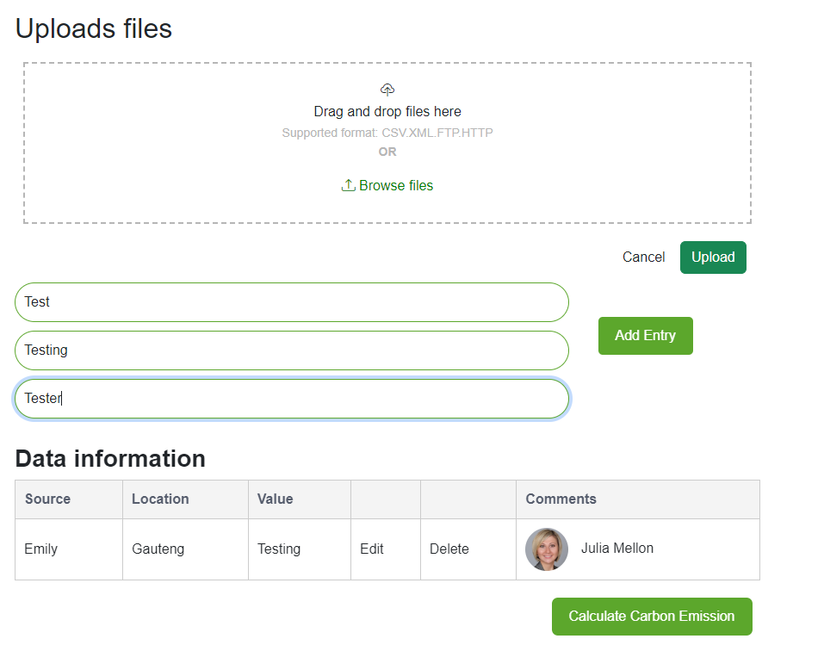
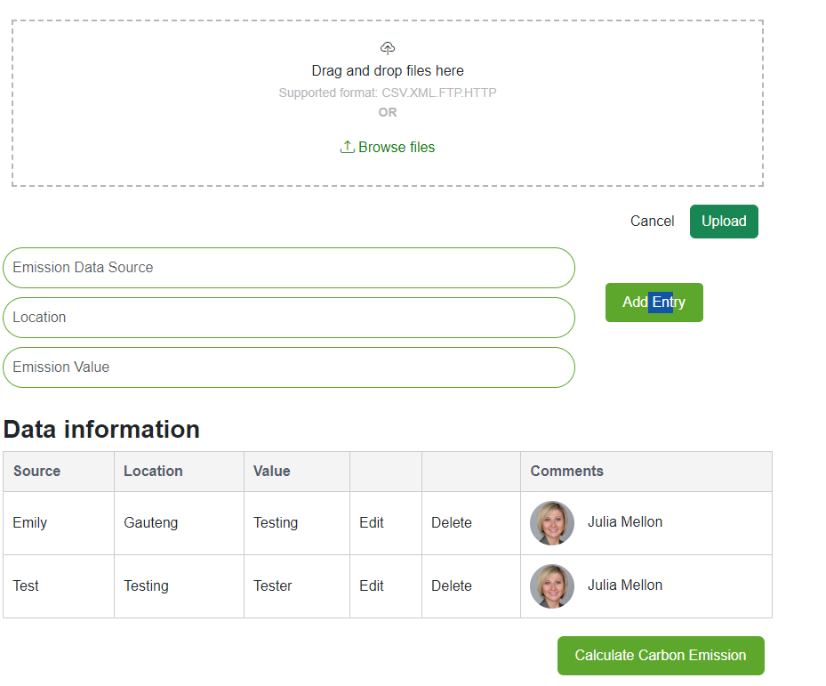
As this is a static application with no data storage, all entered data will be lost upon refreshing the browser. This is illustrated in the provided screenshots, where the table displays only the data entered during the current session.

The updated landing page is designed to be more user-friendly and engaging, incorporating new features to improve navigation and user experience. These enhancements aim to attract more clients and increase traffic to our website.
The website url: https://66817c88cd6edb0e2628670e--cool-sfogliatella-670c97.netlify.app/
The github code.: https://github.com/Clearance93/EmissionTrack.git

That is for the source code.
any question please don’t hesitate to contact me.

